Week 8 Pima Woman Predictive Model

Shawn T Storm
Colorado State University Global
CSC 484: Advanced Topics in Software Development with Python
Prof. Cooper

Project Description:
The Pima Woman Predictive Model was built using the Pima Indians Diabetes Database provided for this assignment. I wanted the project to be a little more interactive than a basic command-line prediction, so the program lets the user build a hypothetical subject by adjusting the same types of measurements used in the dataset. Once the subject is created, the program passes those values through the trained neural network and displays the model’s diabetes probability.
The learning process uses the supplied Pima records to train a small neural network. The data is divided into training and testing groups, the input values are normalized, and the network adjusts its weights during repeated training cycles using backpropagation and gradient descent. The final prediction comes from the trained model rather than from manually written rules. One of the main challenges during development was keeping the project simple enough for the course while still making it useful and interactive. I also had to adjust how the program locates the CSV file so it works reliably when moved to another folder or downloaded from GitHub.
The final version keeps the assigned dataset as the focus and reduces unnecessary dependencies. The program requires Python 3 and NumPy to run. NumPy can be installed with py -m pip install numpy, and the pima_diabetes.csv file should remain in the same project folder as the Python program.

Screenshots:
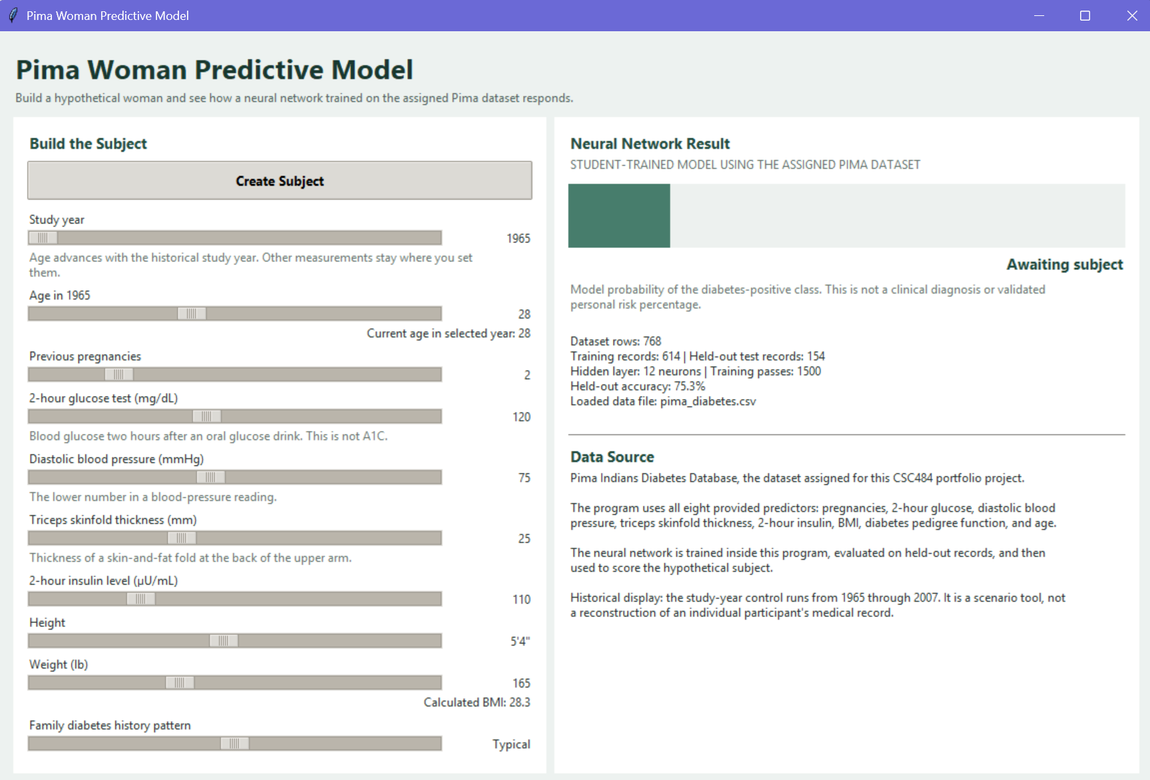
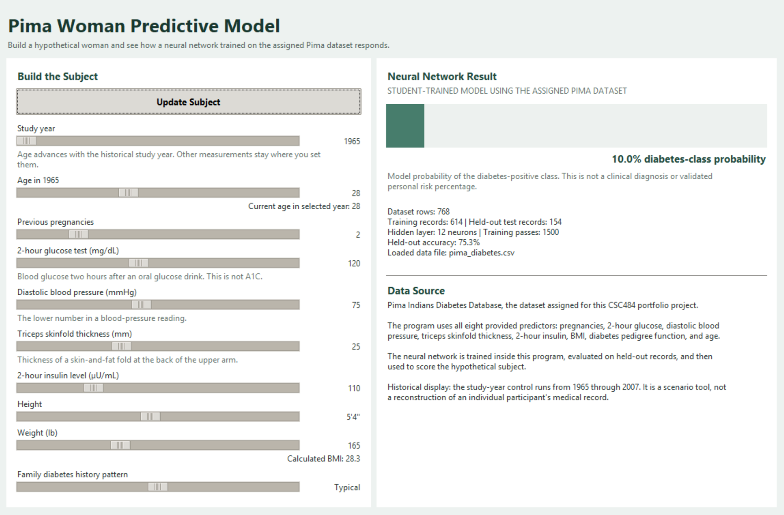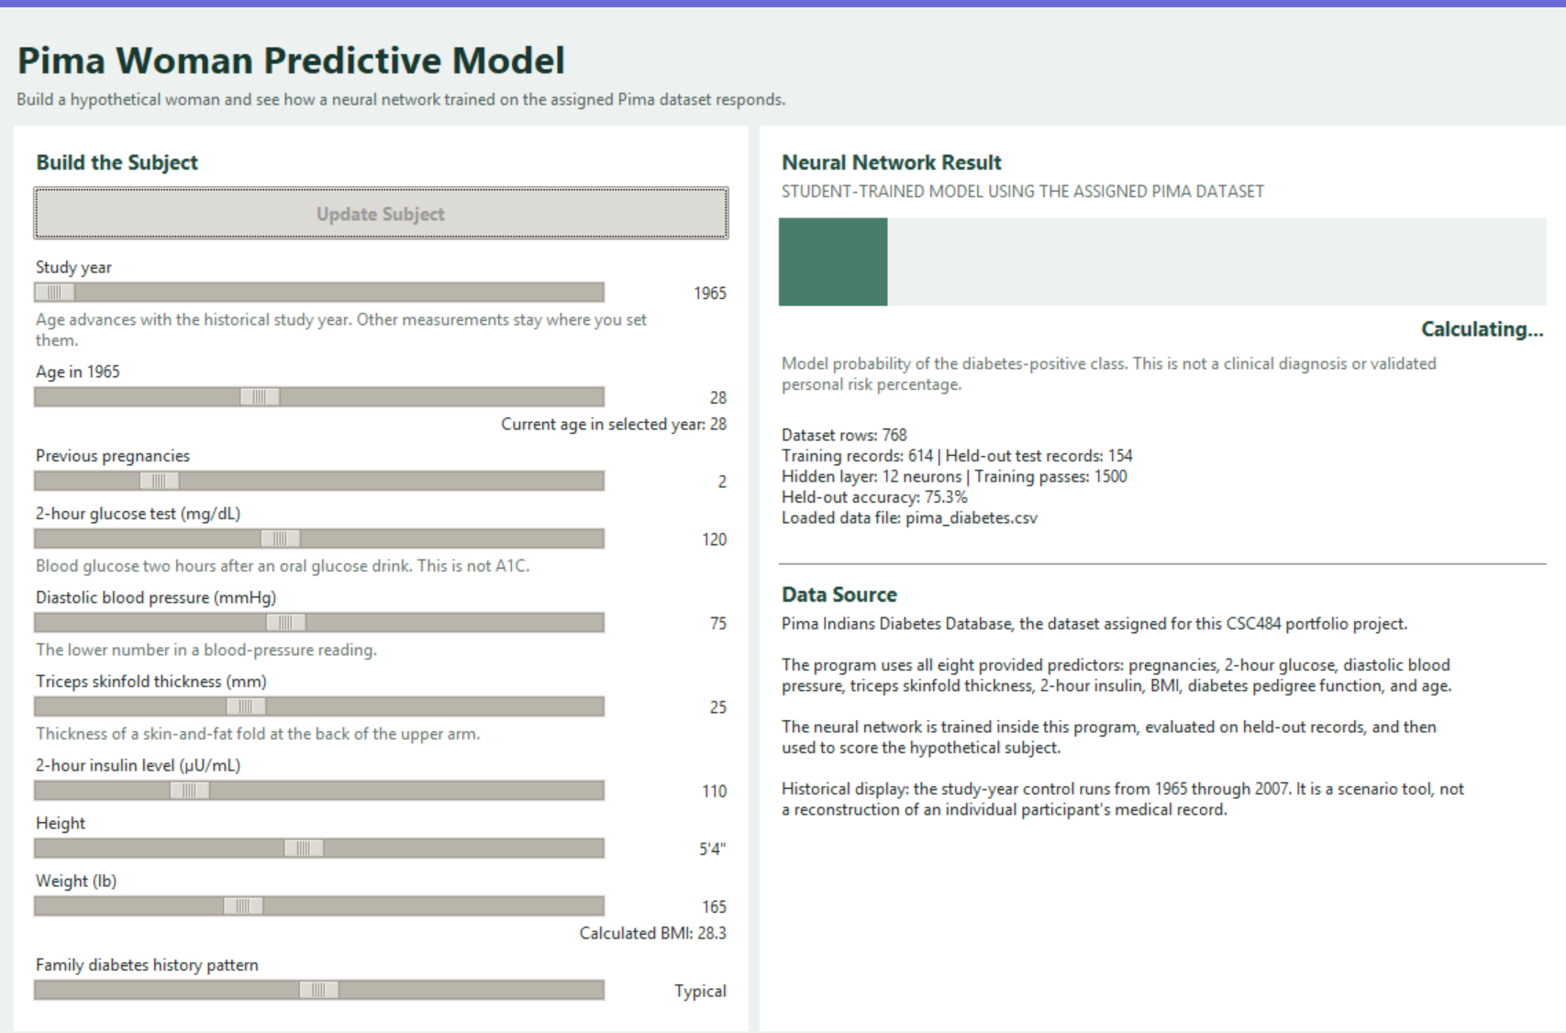

Pseudocode:
PIMA WOMAN PREDICTIVE MODEL

START PROGRAM

SET the program folder as the base folder
DEFINE accepted names for the Pima diabetes CSV
DEFINE the eight Pima predictor fields
DEFINE study years 1965 through 2007
SET a repeatable random seed

FIND DATASET
FIND the folder that contains the running Python program
LOOK for pima_diabetes.csv beside the Python program
ALSO allow the common Pima filename or a data subfolder as fallback locations
DO NOT depend on the terminal's current working directory
ACCEPT a file when it has the expected 9-column Pima structure
IF no valid dataset is found
SHOW the exact expected dataset path
STOP model training

LOAD DATA
READ the Pima CSV into a numeric array
SEPARATE the first eight columns as input features
SEPARATE the ninth column as the diabetes outcome
FOR glucose, blood pressure, skinfold thickness, insulin, and BMI
CHANGE impossible zero values to missing values

PREPARE DATA
SEPARATE positive and negative outcome records
SHUFFLE each group using the fixed random seed
PLACE about 80 percent of each group in training data
PLACE the remainder in held-out test data
CALCULATE median replacement values from training records only
REPLACE missing values with those medians
CALCULATE training means and standard deviations
STANDARDIZE all feature values using the training statistics

DEFINE NEURAL NETWORK
CREATE 8 input values
CREATE 12 hidden neurons
USE ReLU activation in the hidden layer
CREATE 1 output neuron
USE sigmoid activation for the output probability
INITIALIZE weights with small random values

TRAIN NEURAL NETWORK
REPEAT for 1500 training passes
RUN the training records forward through the network
CALCULATE prediction error against the known outcomes
BACKPROPAGATE the error through the network
UPDATE weights and biases using gradient descent

EVALUATE MODEL
RUN held-out test records through the trained network
CLASSIFY probabilities at a 0.50 threshold
CALCULATE held-out accuracy
SAVE model weights, preprocessing values, and model statistics

BUILD USER INTERFACE
SHOW the title and project explanation
SHOW the Create Subject button near the top of the subject panel
SHOW controls for:
study year
age in 1965
previous pregnancies
2-hour glucose
diastolic blood pressure
triceps skinfold thickness
2-hour insulin
height
weight
family diabetes history pattern
CALCULATE BMI from height and weight
CALCULATE current age from baseline age and selected study year
SHOW model training information and loaded dataset filename
SHOW the assigned Pima dataset as the project data source

WHILE waiting for a subject
MOVE the result bar slowly as a visual idle effect
DO NOT display the random motion as a real prediction

WHEN user selects CREATE SUBJECT
COLLECT the current form values
CALCULATE BMI
MAP family-history choice to a pedigree value from dataset quartiles
CALCULATE current age for the selected study year
STANDARDIZE the subject using saved training statistics
RUN the subject through the trained neural network
STORE the model probability
SPEED UP the result animation briefly
GRADUALLY settle the result bar toward the real model probability
DISPLAY the final diabetes-class probability
CHANGE button text to UPDATE SUBJECT

END PROGRAM when the window closes

Program Code:

"""
Pima Woman Predictive Model - CSC484 Portfolio Project

A small educational neural network trained only on the assigned Pima Indians
Diabetes dataset. The interface lets the user build a hypothetical woman,
move her through the 1965-2007 study period, and see how the trained model
responds to the selected measurements.

This program is for education only. The percentage is model output, not a
clinical diagnosis or validated medical risk estimate.
"""

import random
import tkinter as tk
from pathlib import Path
from tkinter import ttk, messagebox

import numpy as np

# 1. PROJECT SETTINGS
BASE = Path(__file__).resolve().parent
DATA_NAMES = ["pima_diabetes.csv", "pima-indians-diabetes.data.csv"]
FEATURES = [
"Pregnancies", "Glucose", "BloodPressure", "SkinThickness",
"Insulin", "BMI", "Pedigree", "Age"
]
START_YEAR, END_YEAR, SEED = 1965, 2007, 42

# These values are filled when the model is trained.
MODEL = {}
STATS = {}
PEDIGREE_LEVELS = [0.25, 0.50, 0.75]

# 2. LOAD AND PREPARE THE ASSIGNED PIMA DATA
def find_data_file():
# Resolve the dataset from the program's own folder, not the folder used
# to launch Python. This keeps the project portable when cloned from GitHub.
candidates = [
BASE / "pima_diabetes.csv",
BASE / "pima-indians-diabetes.data.csv",
BASE / "data" / "pima_diabetes.csv",
BASE / "data" / "pima-indians-diabetes.data.csv",
]
for path in candidates:
if not path.exists():
continue
try:
sample = np.loadtxt(path, delimiter=",")
if sample.ndim == 2 and sample.shape[1] == 9 and len(sample) >= 700:
return path, sample
except (ValueError, OSError):
pass
expected = BASE / "pima_diabetes.csv"
raise FileNotFoundError(
f"Pima dataset not found. Expected: {expected}\n"
"Keep pima_diabetes.csv in the same folder as this Python program."
)

def load_data():
data_file, data = find_data_file()
x = data[:, :8].astype(float)
y = data[:, 8].astype(float).reshape(-1, 1)

# Zero is not a realistic value for these measurements. In the original
# classroom file, zeros are commonly treated as missing measurements.
for col in [1, 2, 3, 4, 5]:
x[x[:, col] == 0, col] = np.nan
return x, y, data_file

def split_data(x, y):
rng = np.random.default_rng(SEED)
negative = np.where(y.ravel() == 0)[0]
positive = np.where(y.ravel() == 1)[0]
rng.shuffle(negative)
rng.shuffle(positive)
n0, n1 = int(len(negative) * 0.80), int(len(positive) * 0.80)
train_idx = np.concatenate([negative[:n0], positive[:n1]])
test_idx = np.concatenate([negative[n0:], positive[n1:]])
rng.shuffle(train_idx)
rng.shuffle(test_idx)
return train_idx, test_idx

def prepare_data(x, train_idx):
medians = np.nanmedian(x[train_idx], axis=0)
clean = np.where(np.isnan(x), medians, x)
means = clean[train_idx].mean(axis=0)
stds = clean[train_idx].std(axis=0)
stds[stds == 0] = 1
return (clean - means) / stds, medians, means, stds

# 3. DEFINE, FIT, EVALUATE, AND USE A SMALL NEURAL NETWORK
def sigmoid(z):
return 1.0 / (1.0 + np.exp(-np.clip(z, -30, 30)))

def train_model():
"""Train an 8 -> 12 -> 1 feed-forward neural network with gradient descent."""
global MODEL, STATS, PEDIGREE_LEVELS
x, y, data_file = load_data()
train_idx, test_idx = split_data(x, y)
x_scaled, medians, means, stds = prepare_data(x, train_idx)
x_train, y_train = x_scaled[train_idx], y[train_idx]
x_test, y_test = x_scaled[test_idx], y[test_idx]

# Map the unfamiliar pedigree score to dataset quartiles for the interface.
pedigree = x[:, 6][~np.isnan(x[:, 6])]
PEDIGREE_LEVELS = np.quantile(pedigree, [0.25, 0.50, 0.75]).tolist()

rng = np.random.default_rng(SEED)
w1 = rng.normal(0, 0.30, (8, 12))
b1 = np.zeros((1, 12))
w2 = rng.normal(0, 0.30, (12, 1))
b2 = np.zeros((1, 1))
learning_rate = 0.02
epochs = 1500

# Forward pass, measure error, backpropagate, then adjust weights.
for _ in range(epochs):
z1 = x_train @ w1 + b1
hidden = np.maximum(z1, 0) # ReLU hidden layer
probs = sigmoid(hidden @ w2 + b2) # Sigmoid output layer

output_error = (probs - y_train) / len(y_train)
dw2 = hidden.T @ output_error
db2 = output_error.sum(axis=0, keepdims=True)
hidden_error = (output_error @ w2.T) * (z1 > 0)
dw1 = x_train.T @ hidden_error
db1 = hidden_error.sum(axis=0, keepdims=True)

w1 -= learning_rate * dw1
b1 -= learning_rate * db1
w2 -= learning_rate * dw2
b2 -= learning_rate * db2

test_probs = sigmoid(np.maximum(x_test @ w1 + b1, 0) @ w2 + b2)
predictions = (test_probs >= 0.50).astype(float)
accuracy = float((predictions == y_test).mean())

MODEL = {"w1": w1, "b1": b1, "w2": w2, "b2": b2,
"medians": medians, "means": means, "stds": stds}
STATS = {"rows": len(x), "train": len(train_idx), "test": len(test_idx),
"accuracy": accuracy, "epochs": epochs, "file": data_file.name}

def predict_probability(values):
row = np.array(values, dtype=float)
row = np.where(np.isnan(row), MODEL["medians"], row)
row = (row - MODEL["means"]) / MODEL["stds"]
hidden = np.maximum(row @ MODEL["w1"] + MODEL["b1"], 0)
return float(sigmoid(hidden @ MODEL["w2"] + MODEL["b2"]).ravel()[0])

def bmi(height_in, weight_lb):
return 703 * weight_lb / (height_in ** 2)

# 4. TKINTER USER INTERFACE
class App:
def __init__(self, root):
self.root = root
self.result_ready = False
self.target = 0.0
self.anim_step = 0
root.title("Pima Woman Predictive Model")
root.geometry("1160x760")
root.minsize(1000, 700)
self._styles()

outer = ttk.Frame(root, padding=16)
outer.pack(fill="both", expand=True)
ttk.Label(outer, text="Pima Woman Predictive Model", style="Title.TLabel").pack(anchor="w")
ttk.Label(
outer,
text="Build a hypothetical woman and see how a neural network trained on the assigned Pima dataset responds.",
style="Sub.TLabel"
).pack(anchor="w", pady=(0, 10))

body = ttk.Frame(outer)
body.pack(fill="both", expand=True)
body.columnconfigure(0, weight=1)
body.columnconfigure(1, weight=1)
body.rowconfigure(0, weight=1)
self.left = ttk.Frame(body, style="Card.TFrame", padding=14)
self.left.grid(row=0, column=0, sticky="nsew", padx=(0, 8))
self.right = ttk.Frame(body, style="Card.TFrame", padding=14)
self.right.grid(row=0, column=1, sticky="nsew")

self.vars, self.value_labels = {}, {}
self._build_inputs()
self._build_results()
self.status = tk.StringVar(value="Training the neural network on the assigned Pima data...")
ttk.Label(outer, textvariable=self.status, style="Sub.TLabel").pack(anchor="w", pady=(8, 0))

# Train once at startup, then reuse those learned weights for each subject.
try:
train_model()
self._training_done()
except Exception as exc:
messagebox.showerror("Startup Error", str(exc))
self.status.set("Model could not be trained.")

self.root.after(500, self._idle_motion)

def _styles(self):
style = ttk.Style()
style.theme_use("clam")
style.configure("TFrame", background="#edf2f0")
style.configure("Card.TFrame", background="#ffffff")
style.configure("Title.TLabel", background="#edf2f0", foreground="#18382f", font=("Segoe UI", 20, "bold"))
style.configure("Sub.TLabel", background="#edf2f0", foreground="#52645e", font=("Segoe UI", 9))
style.configure("Head.TLabel", background="#ffffff", foreground="#214b3f", font=("Segoe UI", 11, "bold"))
style.configure("Card.TLabel", background="#ffffff", foreground="#27342f", font=("Segoe UI", 9))
style.configure("Accent.TButton", font=("Segoe UI", 10, "bold"), padding=8)

def _scale(self, key, label, low, high, default, note="", formatter=None):
ttk.Label(self.left, text=label, style="Card.TLabel").pack(anchor="w", pady=(4, 0))
row = ttk.Frame(self.left, style="Card.TFrame")
row.pack(fill="x")
var = tk.DoubleVar(value=default)
self.vars[key] = var
ttk.Scale(row, from_=low, to=high, variable=var).pack(side="left", fill="x", expand=True)
out = ttk.Label(row, width=13, anchor="e", style="Card.TLabel")
out.pack(side="right", padx=(8, 0))
self.value_labels[key] = out

def refresh(*_):
value = var.get()
out.config(text=formatter(value) if formatter else f"{value:.0f}")
self._update_derived()
var.trace_add("write", refresh)
refresh()
if note:
ttk.Label(self.left, text=note, style="Card.TLabel", foreground="#68766f", wraplength=470).pack(anchor="w")

def _build_inputs(self):
ttk.Label(self.left, text="Build the Subject", style="Head.TLabel").pack(anchor="w")
self.build_btn = ttk.Button(self.left, text="Create Subject", style="Accent.TButton", command=self.create_subject)
self.build_btn.pack(fill="x", pady=(6, 6))
self._scale("year", "Study year", START_YEAR, END_YEAR, 1965,
"Age advances with the historical study year. Other measurements stay where you set them.")
self._scale("base_age", "Age in 1965", 21, 39, 28)
self.age_text = tk.StringVar()
ttk.Label(self.left, textvariable=self.age_text, style="Card.TLabel").pack(anchor="e")
self._scale("preg", "Previous pregnancies", 0, 10, 2)
self._scale("glucose", "2-hour glucose test (mg/dL)", 60, 200, 120,
"Blood glucose two hours after an oral glucose drink. This is not A1C.")
self._scale("dbp", "Diastolic blood pressure (mmHg)", 40, 120, 75,
"The lower number in a blood-pressure reading.")
self._scale("skin", "Triceps skinfold thickness (mm)", 5, 60, 25,
"Thickness of a skin-and-fat fold at the back of the upper arm.")
self._scale("insulin", "2-hour insulin level (µU/mL)", 10, 400, 110)
self._scale("height", "Height", 55, 74, 64, formatter=lambda x: f"{int(x)//12}'{int(x)%12}\"")
self._scale("weight", "Weight (lb)", 90, 300, 165)
self.bmi_text = tk.StringVar()
ttk.Label(self.left, textvariable=self.bmi_text, style="Card.TLabel").pack(anchor="e")
self._scale("ped", "Family diabetes history pattern", 0, 2, 1,
"Lower / Typical / Higher maps to quartiles of the dataset's pedigree score.",
formatter=lambda x: ["Lower", "Typical", "Higher"][round(x)])

self._update_derived()

def _build_results(self):
ttk.Label(self.right, text="Neural Network Result", style="Head.TLabel").pack(anchor="w")
ttk.Label(self.right, text="STUDENT-TRAINED MODEL USING THE ASSIGNED PIMA DATASET", style="Card.TLabel", foreground="#61726b").pack(anchor="w")
self.bar = tk.Canvas(self.right, height=64, bg="#f1f4f2", highlightthickness=0)
self.bar.pack(fill="x", pady=(10, 4))
self.percent = ttk.Label(self.right, text="Awaiting subject", style="Head.TLabel")
self.percent.pack(anchor="e")
ttk.Label(self.right, text="Model probability of the diabetes-positive class. This is not a clinical diagnosis or validated personal risk percentage.", style="Card.TLabel", foreground="#68766f", wraplength=500).pack(anchor="w", pady=(4, 14))

self.metrics = tk.StringVar(value="Model training pending...")
ttk.Label(self.right, textvariable=self.metrics, style="Card.TLabel", wraplength=500, justify="left").pack(anchor="w", pady=(4, 16))
ttk.Separator(self.right).pack(fill="x", pady=8)
ttk.Label(self.right, text="Data Source", style="Head.TLabel").pack(anchor="w")
source = (
"Pima Indians Diabetes Database, the dataset assigned for this CSC484 portfolio project.\n\n"
"The program uses all eight provided predictors: pregnancies, 2-hour glucose, diastolic blood pressure, triceps skinfold thickness, 2-hour insulin, BMI, diabetes pedigree function, and age.\n\n"
"The neural network is trained inside this program, evaluated on held-out records, and then used to score the hypothetical subject.\n\n"
"Historical display: the study-year control runs from 1965 through 2007. It is a scenario tool, not a reconstruction of an individual participant's medical record."
)
ttk.Label(self.right, text=source, style="Card.TLabel", wraplength=500, justify="left").pack(anchor="w")

def _training_done(self):
self.metrics.set(
f"Dataset rows: {STATS['rows']}\n"
f"Training records: {STATS['train']} | Held-out test records: {STATS['test']}\n"
f"Hidden layer: 12 neurons | Training passes: {STATS['epochs']}\n"
f"Held-out accuracy: {STATS['accuracy']:.1%}\n"
f"Loaded data file: {STATS['file']}"
)
self.status.set("Model trained. Build the subject, then choose Create Subject.")

def _update_derived(self):
if not hasattr(self, "age_text") or "year" not in self.vars or "base_age" not in self.vars:
return
age = round(self.vars["base_age"].get()) + round(self.vars["year"].get()) - START_YEAR
self.age_text.set(f"Current age in selected year: {age}")
if hasattr(self, "bmi_text") and "height" in self.vars and "weight" in self.vars:
self.bmi_text.set(f"Calculated BMI: {bmi(self.vars['height'].get(), self.vars['weight'].get()):.1f}")

def _draw_bar(self, value):
self.bar.update_idletasks()
width = max(self.bar.winfo_width(), 420)
self.bar.delete("all")
self.bar.create_rectangle(0, 0, width, 64, fill="#edf1ef", outline="")
self.bar.create_rectangle(0, 0, width * max(0, min(1, value)), 64, fill="#477d6c", outline="")

def _idle_motion(self):
if not self.result_ready and self.anim_step == 0:
self._draw_bar(random.uniform(0.18, 0.78))
self.root.after(650, self._idle_motion)

def create_subject(self):
age = round(self.vars["base_age"].get()) + round(self.vars["year"].get()) - START_YEAR
pedigree = PEDIGREE_LEVELS[round(self.vars["ped"].get())]
values = [
self.vars["preg"].get(), self.vars["glucose"].get(), self.vars["dbp"].get(),
self.vars["skin"].get(), self.vars["insulin"].get(),
bmi(self.vars["height"].get(), self.vars["weight"].get()), pedigree, age
]
self.target = predict_probability(values)
self.result_ready = False
self.anim_step = 1
self.build_btn.config(state="disabled")
self.percent.config(text="Calculating...")
self.status.set("Running the subject through the trained neural network...")
self._settle_animation()

def _settle_animation(self):
progress = min(self.anim_step / 24, 1)
noise = (1 - progress) * 0.30
shown = max(0, min(1, self.target + random.uniform(-noise, noise)))
self._draw_bar(shown)
if progress < 1:
self.anim_step += 1
self.root.after(85 if self.anim_step < 10 else 120, self._settle_animation)
return
self.anim_step = 0
self.result_ready = True
self._draw_bar(self.target)
self.percent.config(text=f"{self.target:.1%} diabetes-class probability")
self.build_btn.config(state="normal", text="Update Subject")
self.status.set("Subject built. Change any measurement and update the subject to compare another scenario.")

def main():
root = tk.Tk()
App(root)
root.mainloop()

if __name__ == "__main__":
main()

Github Link:
https://github.com/miscney1/CSC484-Assignment-8-Pima-Woman-Model

